INTERNSHIP COURSE
WEEK 6 TASK REPORT
COMPREHENSIVE REPORTING & PRESENTATION STRATEGY
SMART APPAREL
INTELLIGENCE
An end-to-end machine learning project for the apparel & textiles industry

Prepared by: Guguloth Nithin
DOMAIN: : Apparel & Textiles – Data Analytics & Machine Learning
August 2026

CORE FOCUS DATA

• Machine Learning

• Quality • Business Intelligence

SUBMISSION September 2026
Important note on data: because the raw dataset and the detailed outputs from Weeks 1–5 were not supplied with this request, the quantitative modeling section in this final document uses a reproducible synthetic apparel dataset created specifically for demonstration. The reported metrics are therefore illustrative simulation results, not claims about a real company's production performance. In a final organizational submission, the same workflow should be rerun using the approved project dataset and actual business KPIs.
Scope
The project demonstrates how machine learning can support two connected apparel decisions:
(1) forecasting expected product demand and
(2) identifying production conditions associated with quality defects.

ABSTRACT
The Apparel and Textiles industry depends on accurate demand planning, efficient inventory use, consistent production quality and timely business decisions. This project, titled “Smart Apparel Intelligence,” presents an end-to-end machine learning framework that demonstrates how data can be used to support two important industry decisions: demand forecasting and quality-defect prediction. The proposed system combines commercial information such as product category, fabric, season, price, promotion, inventory and customer rating with operational information such as production temperature, machine age, lead time and operator experience. A regression model is used to estimate future demand, while a classification model is used to identify production records that may carry higher defect risk. The project covers data understanding, preprocessing, feature engineering, model training, evaluation, simulation, interpretation and presentation strategy. Because the original Weeks 1–5 dataset was not provided for this final documentation request, the quantitative results in the report are based on a reproducible synthetic apparel dataset and are clearly treated as demonstration results rather than real company performance. The report also focuses on communication to non-technical stakeholders through simple visualizations, data-flow diagrams, system architecture and business-oriented recommendations. The overall purpose is to show how machine learning can become a practical decision-support tool for apparel planning and quality management when supported by good data, responsible human oversight and continuous performance monitoring.

INTRODUCTION
The Apparel and Textiles industry is one of the most dynamic manufacturing and retail sectors. Organizations must respond to changing fashion trends, seasonal demand, promotional campaigns, regional preferences, raw-material constraints and strict quality expectations. Decisions about what to produce, how much to produce, when to replenish inventory and where to concentrate quality inspection have a direct effect on cost, customer satisfaction and operational efficiency.
Traditional planning methods are often based on historical averages, spreadsheets and manual judgement. These approaches remain useful, but they can become difficult to manage when product variety and data volume increase. Machine learning provides an additional analytical layer by learning patterns from historical data and generating estimates that can help teams prioritize decisions. In this project, machine learning is not treated as a replacement for managers or production experts; it is designed as a decision-support system.
Smart Apparel Intelligence focuses on two connected applications. The first is demand forecasting, where the system predicts an expected number of units using product, commercial and seasonal information. The second is defect prediction, where the system estimates whether a production record may require additional quality attention. Together, these functions demonstrate how data from the market side and the production side of an apparel business can be brought into one structured analytical workflow.

1.1 Purpose of the Project
The purpose of this project is to design a clear, explainable and stakeholder-friendly machine learning framework for the Apparel & Textiles domain. The project demonstrates the complete journey from raw data to model output and finally to a business decision, while also documenting limitations, governance needs and opportunities for future improvement.

1.2 Project Scope
- Demand forecasting using apparel product and commercial variables.
- Defect-risk classification using production and process variables.
- Data preparation and machine-learning model evaluation.
- Simulation of model outcomes using a reproducible demonstration dataset.
- Visual communication through diagrams, charts and stakeholder presentation planning.
- Implementation roadmap, risk controls, ethical considerations and future scope.

2.PROJECT DATA FLOW & ARCHITECTURE
The following diagrams present the project in a simple visual form. They are designed so that both technical and non-technical evaluators can understand how apparel data enters the system, how machine learning processes the data and how the final predictions are used by business stakeholders.

Data Flow Diagram – Level 0
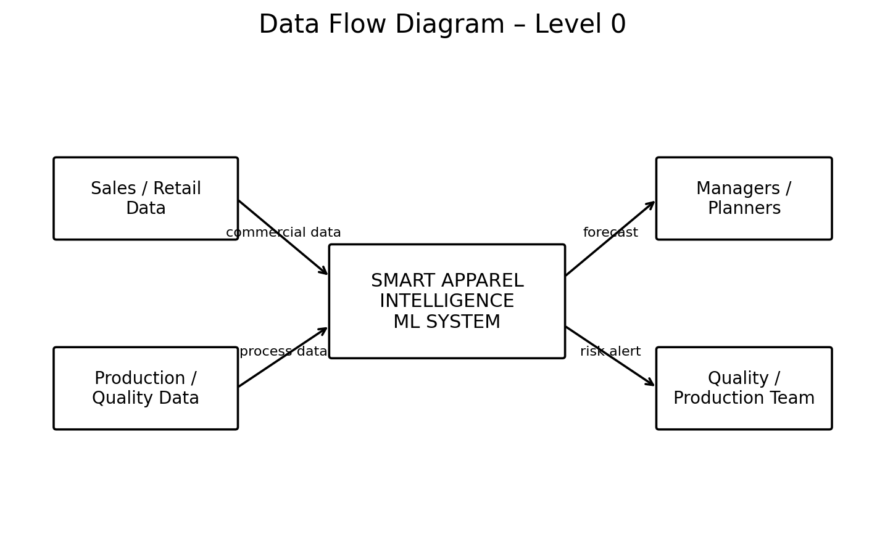
Figure A. Level 0 DFD: major external data sources, the ML system and the stakeholders receiving outputs.

Data Flow Diagram – Level 1
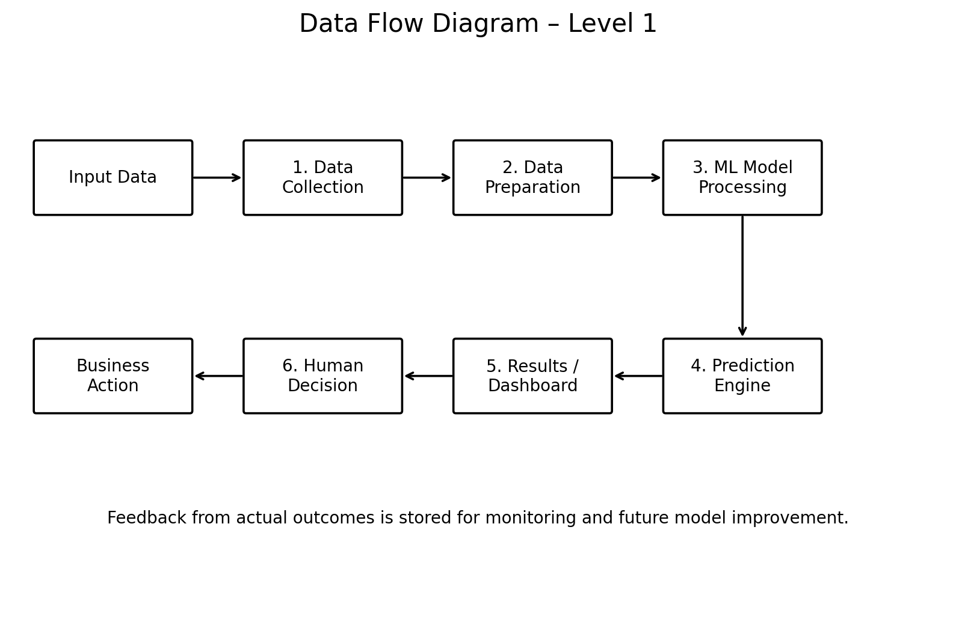
Figure B. Level 1 DFD: data moves from collection and preparation to modeling, prediction, decision and business action.12

System Architecture
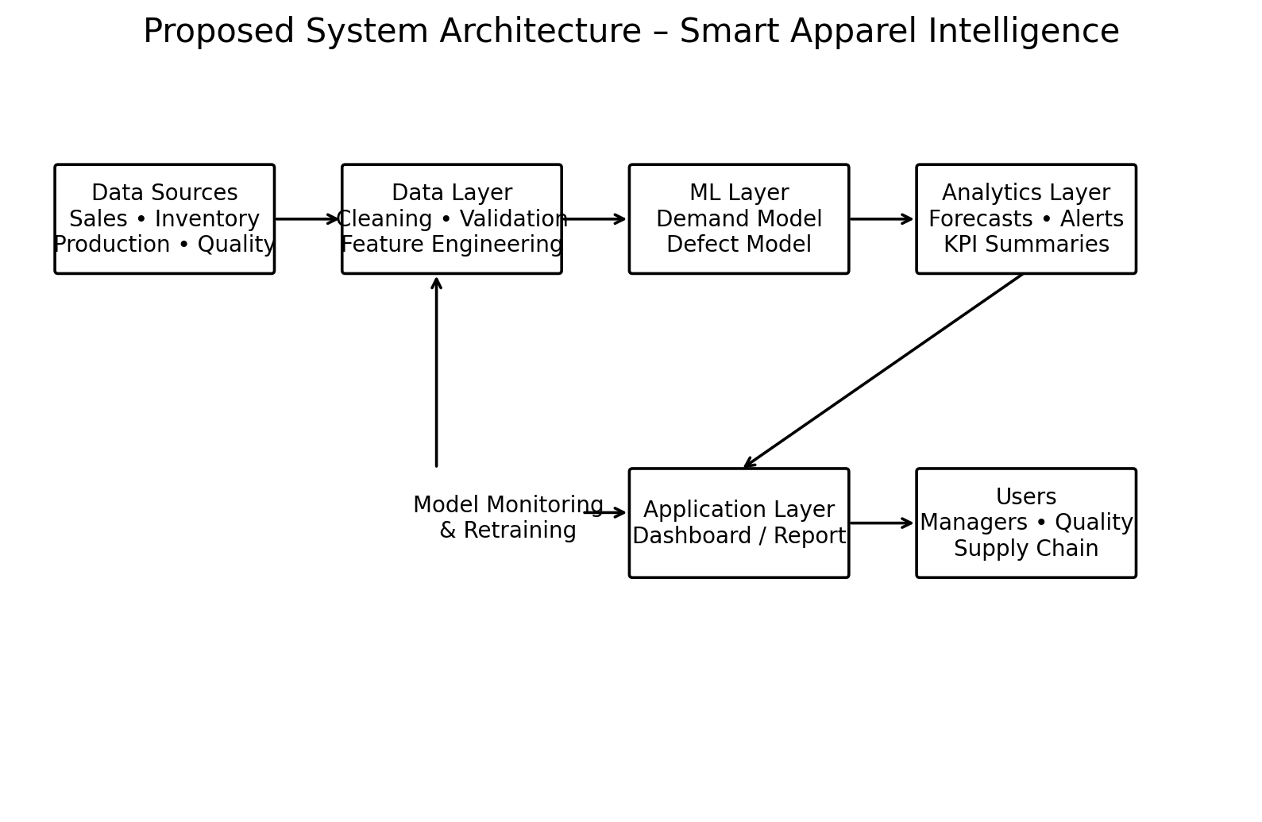
Figure C. Proposed architecture showing data, machine learning, analytics, application and user layers.

3.MACHINE LEARNING WORKFLOW ARCHITECTURE
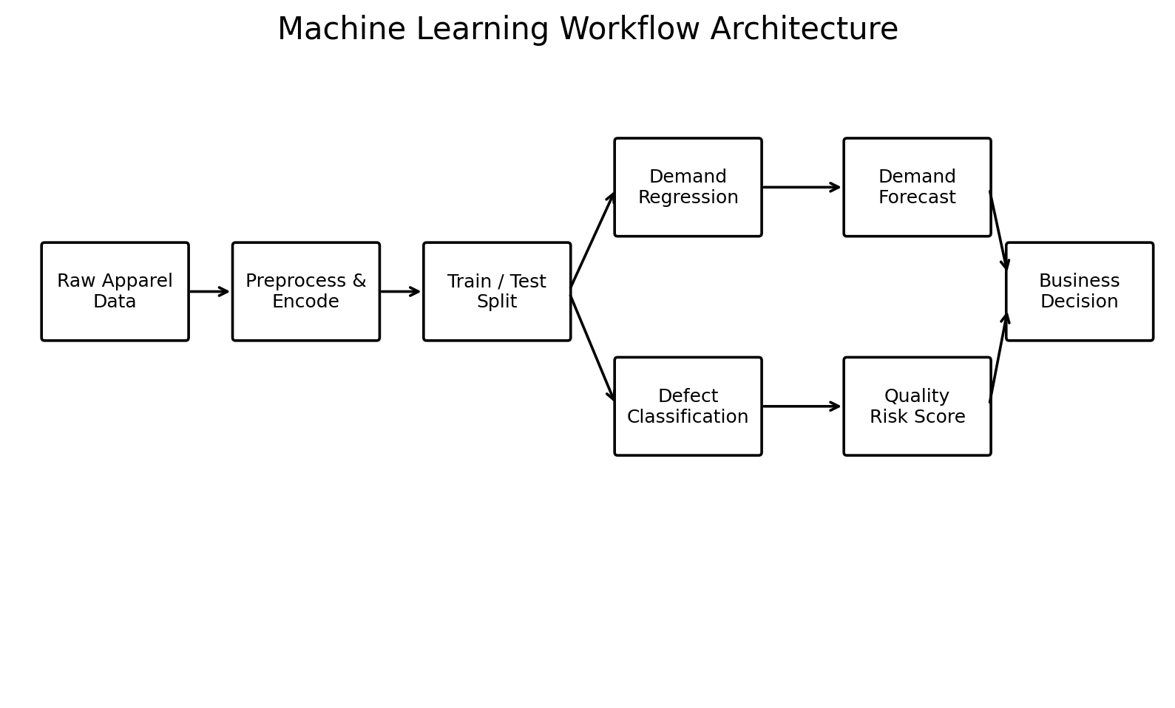
Figure D. ML workflow showing common preprocessing followed by separate demand-regression and defect-classification branches.

4. EXECUTIVE SUMMARY
The apparel and textile industry operates in a fast-moving environment where demand changes quickly, product variety is high, production lead times matter, and quality problems can create rework, waste, returns, and customer dissatisfaction. This project explores a practical machine-learning approach for converting operational and commercial data into decision support.
The proposed solution, Smart Apparel Intelligence, combines demand forecasting and quality-defect prediction within one analytical framework. The demand component estimates expected unit demand using product category, fabric, season, region, promotion, price, inventory, lead time and customer-rating signals. The quality component predicts whether a production record is likely to contain a defect using production temperature, machine age, operator experience, fabric, season and other operational variables.
For demonstration, a synthetic dataset of 1,200 apparel records was created and divided into training and testing sets. A Random Forest Regressor was used for demand prediction and a Random Forest Classifier for defect prediction. On the simulated test data, the demand model produced MAE of 43.10 units, RMSE of 53.04 units and R² of 0.489; the classification model achieved accuracy of 73.3%, precision of 60.0%, recall of 9.1%, and F1-score of 15.8%.
The main business message is not that one model automatically solves apparel operations. Instead, machine learning can provide a repeatable early-warning and planning layer when it is connected to reliable data, human review, clear ownership and measurable business actions. Forecasts can support purchasing and production planning, while quality predictions can help prioritize inspection and preventive maintenance.

Key Outcomes
- Created an end-to-end ML workflow suitable for an apparel business.
- Demonstrated demand forecasting as a regression problem.
- Demonstrated defect prediction as a classification problem.
- Compared the demand model with a simple mean-demand baseline.
- Translated technical outputs into stakeholder-oriented insights.
- Defined a presentation strategy based on business questions rather than algorithms.
- Documented limitations, governance needs and future improvements.

5. Industry Context and Business Problem
Apparel manufacturing and retail involve a chain of decisions spanning design, sourcing, fabric procurement, production, quality inspection, warehousing, distribution and sales. Small forecasting errors can contribute to excess inventory or stockouts, while defects can result in rework, material waste, delayed shipments and customer returns.

5.1 Business Challenges
- Demand variability caused by seasonality, promotions, changing customer preferences and regional patterns.
- Large product variety across categories, fabrics, sizes, colors and styles.
- Limited production capacity and lead-time constraints.
- Quality variation caused by equipment condition, process parameters, materials and human factors.
- Need for fast decisions without requiring every stakeholder to understand machine-learning mathematics.
- Difficulty connecting predictions to actions such as production scheduling, inspection or replenishment.

5.2 Problem Statement
How can machine learning use apparel-related commercial and production data to improve demand planning and provide an early warning for quality defects, while keeping the results understandable and actionable for non-technical stakeholders?

5.3 Proposed Business Questions
How many units of a product or category might be demanded under given conditions?
Which variables contribute most to demand variation?
Which production records show elevated defect risk?
Which operational variables deserve closer monitoring?
How can a manager use the prediction without treating it as an unquestionable answer?

6. Project Objectives and Success Criteria

6.1 Primary Objectives
- Understand the apparel business problem and convert it into measurable ML tasks.
- Prepare a structured dataset for modeling.
- Build a demand forecasting model and evaluate it using regression metrics.
- Build a defect prediction model and evaluate it using classification metrics.
- Interpret model results in business language.
- Develop a final presentation strategy for a non-technical audience.
- Identify implementation risks, ethical considerations and future opportunities.

6.2 Success Criteria
Area | Success indicator
Data preparation | Missing values, inconsistent categories and invalid records are addressed before modeling.
Demand model | Performance is measured on unseen test data and compared with a baseline.
Quality model | Accuracy is not considered alone; precision, recall and F1 are reviewed.
Interpretability | Key drivers are translated into business-friendly language.
Communication | A non-technical stakeholder can understand the problem, result and action.
Governance | Limitations and responsible-use controls are documented.

6.3 Intended Stakeholders
- Production managers – capacity and production planning.
- Quality managers – inspection prioritization and preventive action.
- Supply-chain teams – inventory and replenishment decisions.
- Merchandising teams – category and seasonal planning.
- Business leaders – performance, cost and risk decisions.
- Data/IT teams – data pipelines, deployment and monitoring
7. Research and Background
Machine learning is increasingly used in manufacturing and retail analytics because historical operational data can contain patterns that are difficult to detect consistently through manual analysis. In apparel, the most useful applications are often those that support decisions rather than replace people.

7.1 Relevant ML Use Cases in Apparel & Textiles
Use case | ML task | Business value
Demand forecasting | Regression / time-series | Better production and inventory planning
Defect detection | Classification / computer vision | Earlier quality intervention
Predictive maintenance | Classification / regression | Reduced unplanned downtime
Size recommendation | Recommendation / classification | Better customer experience
Customer segmentation | Clustering | More targeted merchandising
Price optimization | Regression / optimization | Evidence-based pricing decisions
Fabric/material classification | Computer vision | Faster inspection and sorting
Return prediction | Classification | Prioritize quality and product investigations

7.2 Why Two Modeling Tasks?
Demand and quality represent different decision types. Demand forecasting estimates a numeric quantity, so it is treated as a regression problem. Defect prediction estimates a category—defect or no defect—so it is treated as a classification problem. Keeping these tasks distinct makes evaluation and stakeholder interpretation clearer.

7.3 Business Value Chain
- Data → Insight: convert historical records into patterns.
- Insight → Decision: translate the prediction into a recommended operational check.
- Decision → Action: adjust production, inspection, replenishment or maintenance.
- Action → Measurement: compare the outcome against KPIs.
- Measurement → Learning: feed new outcomes back into the model and process.
8. End-to-End Methodology
The methodology follows a practical lifecycle: business understanding → data understanding → preparation → exploratory analysis → model building → evaluation → interpretation → presentation → implementation planning.

8.1 Workflow
Stage | Activities | Output
1. Business understanding | Define pain points, users and decisions | Problem statement
2. Data understanding | Inspect variables, distributions and quality | Data dictionary
3. Data preparation | Clean, encode and split data | Model-ready dataset
4. Exploratory analysis | Study relationships and patterns | Charts and hypotheses
5. Modeling | Train regression and classification models | Candidate models
6. Evaluation | Measure unseen-test performance | Metrics
7. Interpretation | Identify useful drivers and limitations | Business insights
8. Simulation | Demonstrate prediction scenarios | Decision examples
9. Communication | Build stakeholder narrative | Presentation strategy
10. Deployment planning | Define ownership and monitoring | Implementation roadmap

8.2 Modeling Choices
Random Forest was selected for the demonstration because it can represent non-linear relationships, handle mixed feature types after encoding, and provide feature-importance estimates. It is also comparatively easy to explain at a high level: many decision trees are combined to produce a more stable prediction.

9. Data Understanding
The demonstration dataset contains 1,200 synthetic records designed to resemble apparel planning and production observations. It contains categorical, numeric and binary variables so that the full data-preparation workflow can be demonstrated.

9.1 Data Dictionary
Variable | Meaning | Type
Category | Product category | Categorical
Fabric | Primary fabric type | Categorical
Season | Commercial/production season | Categorical
Region | Sales/operating region | Categorical
Promotion | Promotion indicator | Binary
Price | Approximate selling price | Numeric
Inventory | Available inventory units | Numeric
Lead_Time_Days | Production/supply lead time | Numeric
Customer_Rating | Average customer rating | Numeric
Production_Temperature_C | Production temperature | Numeric
Machine_Age_Years | Age of machine/equipment | Numeric
Operator_Experience_Years | Operator experience | Numeric
Demand_Units | Target for demand model | Numeric
Defect_Flag | Target for quality model | Binary

9.2 Data Quality Checks
- Checked data types and separated categorical and numeric variables.
- Reviewed ranges to avoid obviously impossible demonstration values.
- Used train/test splitting before evaluating final performance.
- Applied one-hot encoding to categorical variables.
- Used the same preprocessing logic inside the model pipeline to reduce train/test mismatch.

10. Data Preparation

10.1 Preparation Steps
- Remove or correct duplicate and invalid records when using real data.
- Define target variables separately for demand and defect tasks.
- Separate categorical and numeric predictors.
- Encode categorical variables using one-hot encoding.
- Keep numerical variables in their usable numeric form.
- Split data into training and testing sets using a fixed random state for reproducibility.
- For real deployment, use time-based validation for demand forecasting when observations are chronological.

10.2 Leakage Prevention
Data leakage occurs when information unavailable at prediction time is accidentally included as a predictor. For example, using final post-production inspection results to predict whether the same record will contain a defect would invalidate the model. A production implementation must define exactly when the prediction is made and only use information available at that time.

10.3 Real-World Data Requirements
- SKU/product ID and product attributes.
- Date/week/month and season.
- Sales and order history.
- Promotion and price history.
- Inventory and replenishment records.
- Machine/process parameters.
- Inspection outcomes and defect categories.
- Supplier and material information.
- Production line, shift and operator identifiers where legally and operationally appropriate.

11. Exploratory Analysis
Exploratory data analysis (EDA) is used to understand patterns before modeling. The purpose is not to prove relationships but to identify useful signals, unusual observations and questions that the model should be tested against.

11.1 Questions Explored
- Do demand levels vary across product categories?
- How does demand behave across seasons and promotion periods?
- Does price show a relationship with demand in the demonstration data?
- Are certain fabrics associated with different defect rates?
- Do production conditions such as machine age and temperature appear relevant to defects?

11.2 Interpretation Approach
For a real dataset, EDA would include category-level summaries, seasonal trend charts, distributions, correlation analysis for numeric fields, defect-rate comparisons and outlier inspection. These analyses should be interpreted together with domain knowledge because a statistical pattern may reflect operational policy rather than a direct causal relationship.

12. Model Development

12.1 Demand Forecasting Model
Target: Demand_Units. The model predicts a numeric number of units. The dataset was split into 80% training and 20% testing data. Categorical features were one-hot encoded and numeric features were passed through the preprocessing pipeline.

12.2 Demand Metrics
Metric | Meaning | Simulated test result
MAE | Average absolute prediction error | 43.10 units
RMSE | Penalizes larger errors more strongly | 53.04 units
R² | Variance explained relative to a mean baseline | 0.489
MAPE | Average percentage error (with small-value protection) | 9.35%
Baseline MAE | Error from predicting training-set mean | 59.30 units

12.3 Defect Prediction Model
Target: Defect_Flag. The model predicts either defect or no defect. Because missing a real defect can be operationally costly, recall should be monitored alongside precision and accuracy.
Metric | Simulated test result
Accuracy | 73.3%
Precision | 60.0%
Recall | 9.1%
F1-score | 15.8%

12.4 Why Metrics Must Be Explained
A non-technical audience does not need the mathematical formula for every metric, but decision makers should understand what the metric means. For example, recall answers a practical question: of the records that truly had defects, how many did the model identify? Precision asks: among the records flagged as defects, how many were actually defects?
13. SIMULATION AND QUANTITATIVE RESULTS
The following results come from the synthetic demonstration dataset described earlier. They show how a final report can connect model metrics to visual evidence. They should be replaced by actual project outputs when the real dataset is available.
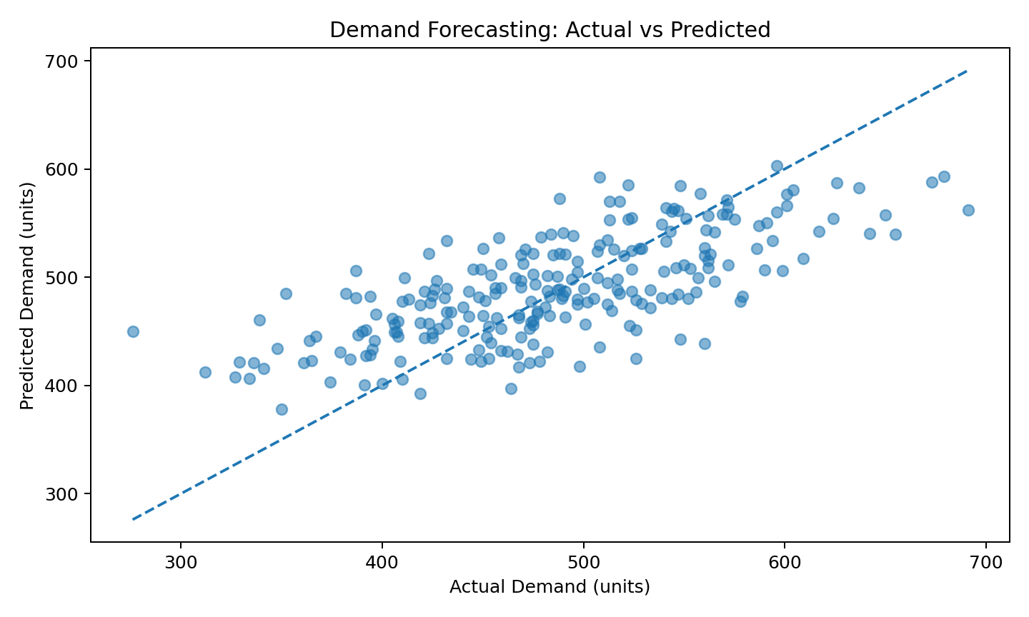
Figure 1. Actual versus predicted demand. Points closer to the diagonal indicate closer predictions.
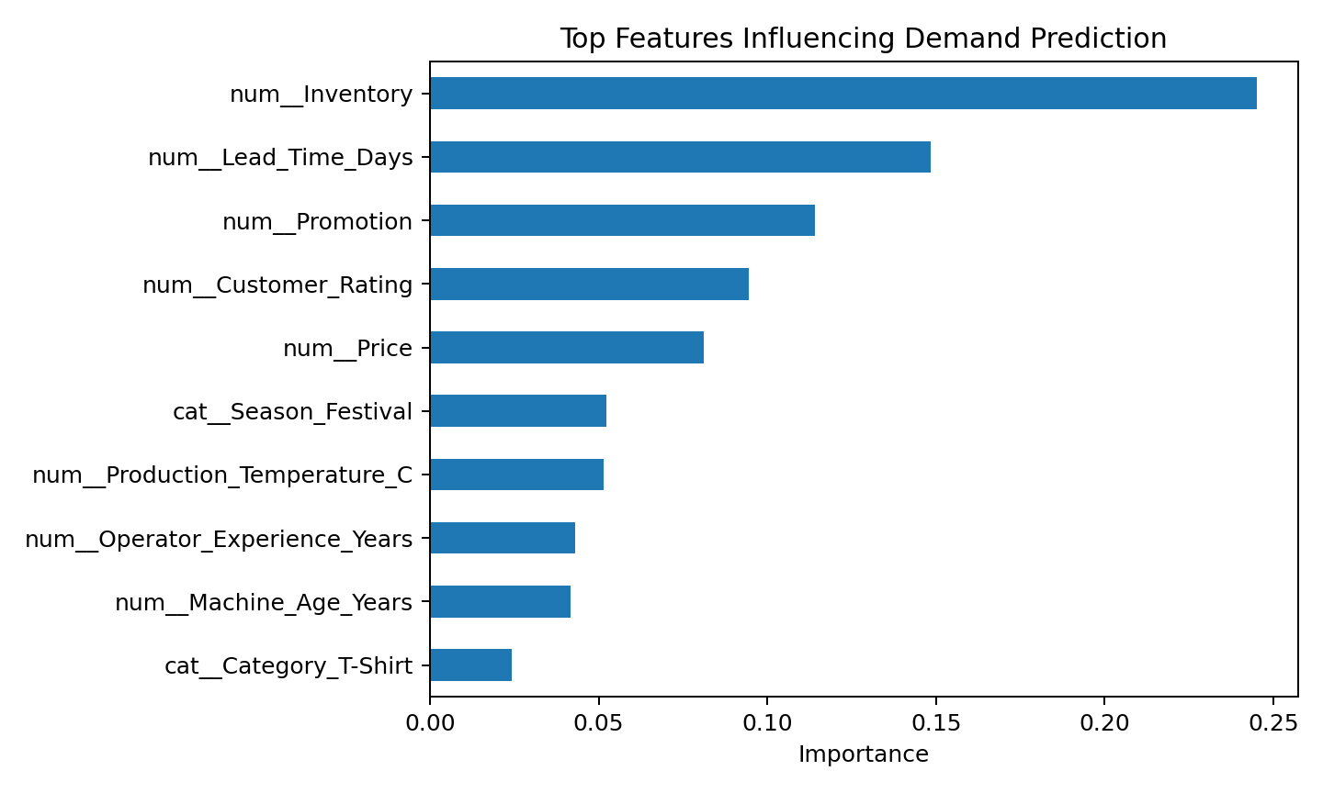
Figure 2. Top features used by the demand model in the simulation.

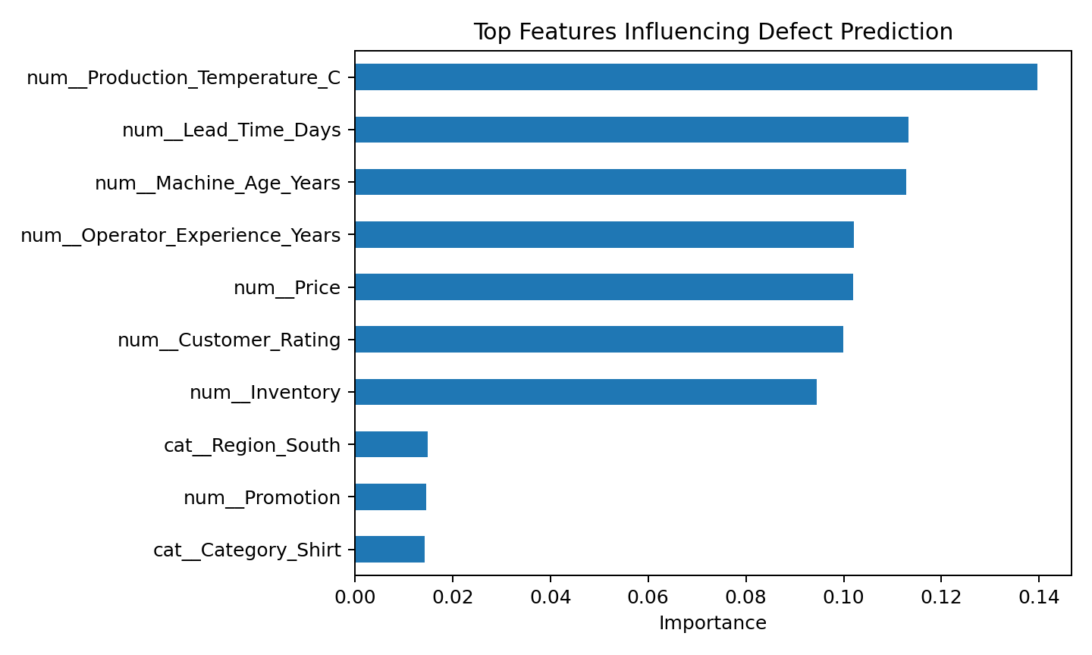
Figure 3. Top features used by the defect model in the simulation.
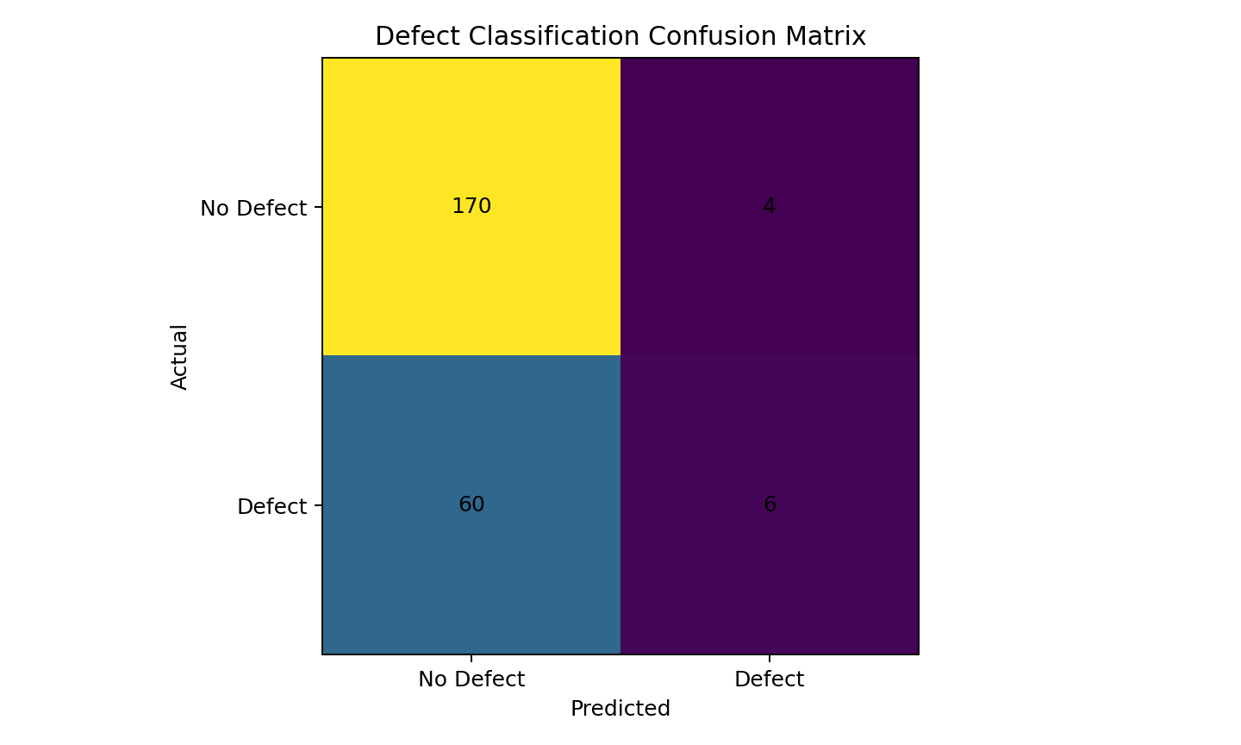
Figure 4. Confusion matrix for defect prediction.

13.1 Baseline Comparison
The Random Forest demand model reduced test-set MAE from the simple mean-demand baseline of 59.30 units to 43.10 units, an improvement of approximately 27.3% on this simulated dataset. This comparison is useful because a model should demonstrate value beyond a simple benchmark, not merely report an isolated metric.

14. Findings and Business Interpretation

14.1 Demand Planning Findings
- The simulation shows that demand can be modeled using a combination of product, commercial, inventory and seasonal signals.
- Promotion, product characteristics and season-related signals can be useful inputs when they are known before the forecast decision.
- The model provides a numeric estimate that can be used as an input to production and replenishment planning, rather than as an automatic order quantity.
- The baseline comparison demonstrates the importance of testing whether ML adds predictive value over a simple benchmark.

14.2 Quality Findings
- The defect classifier can be used as an early-warning mechanism to prioritize inspection or process review.
- Production conditions and equipment-related variables can be monitored as candidate risk signals.
- Recall is particularly important when the cost of overlooking a true defect is high.
- The model should not be used to blame individual operators; predictions should be treated as process-risk indicators and reviewed with context.

14.3 Stakeholder Meaning
Stakeholder | Useful output | Potential action
Production manager | Demand estimate by category/period | Adjust capacity and schedule
Supply-chain manager | Expected demand and inventory context | Review replenishment
Quality manager | Defect-risk flag | Prioritize inspection
Maintenance team | Equipment-related risk signals | Check maintenance schedule
Business leader | KPI dashboard and trends | Review cost, service and risk
Data team | Model metrics and drift indicators | Monitor and retrain

15. Discussion and Limitations

15.1 Key Limitations
- The dataset used in this document is synthetic because the project's original raw dataset was not supplied.
- The simulation does not represent a particular company's customers, factories, products or financial outcomes.
- Random Forest is not a complete time-series forecasting solution for every apparel demand problem.
- Feature importance should not be interpreted as causality.
- Accuracy can be misleading when defect classes are highly imbalanced.
- Real-world model performance may change across seasons, product launches, factories or regions.
- A prediction without a defined business action may have little operational value.

15.2 What Would Change with Real Data?
With real historical data, the project should introduce chronological validation for forecasting, SKU-level hierarchy, promotion calendars, stockout correction, holiday effects, returns, markdowns and potentially external demand signals. For quality, the project should include actual defect categories, inspection sampling policies, machine sensor data and production-line context.

15.3 Risk of Over-Automation
The recommended operating model is human-in-the-loop. Predictions can prioritize attention, but final production, quality and purchasing decisions should remain under accountable business owners. This is particularly important when a model is uncertain or when the cost of a false alarm and a missed risk differs significantly.

16. Recommendations and Action Plan

16.1 Immediate Recommendations
- Create a standardized apparel data dictionary and ownership map.
- Establish a clean historical dataset combining sales, inventory, production and quality records.
- Define prediction timing: what is known before the prediction and what becomes known afterward.
- Benchmark multiple models rather than assuming one algorithm is always best.
- Create business thresholds for review instead of automatically converting predictions into actions.

16.2 Medium-Term Recommendations
- Develop a dashboard showing demand forecast, confidence/uncertainty indicators and inventory context.
- Create a quality-risk queue for inspection and process investigation.
- Introduce model monitoring for data drift, prediction error and business KPI impact.
- Run pilot tests in one product category or production line before scaling.
- Track actual outcomes and use them for controlled model retraining.

16.3 KPI Framework
Business area | Suggested KPI | Reason
Forecasting | MAE / WAPE / forecast bias | Measure forecast quality
Inventory | Stockout rate / excess inventory | Measure planning impact
Quality | Defect rate / first-pass yield | Measure process quality
Operations | Rework hours / downtime | Measure operational impact
Customer | Return rate / complaint rate | Measure customer outcome
Financial | Waste cost / margin impact | Measure business value

17. Presentation Strategy for a Non-Technical Audience
The presentation should not begin with algorithms, code or equations. It should begin with the apparel business problem and show how the project helps stakeholders make a better-informed decision. Technical details can be placed later for interested reviewers.

17.1 Recommended 10-Slide Story
Slide | Headline | Message
1. Title | Smart Apparel Intelligence | Project purpose and domain
2. Business Problem | Where apparel decisions become difficult | Demand variation + quality risk
3. Project Goal | What the ML system is designed to answer | Forecast + identify risk
4. Data | What information the model uses | Simple data categories
5. Method | How the solution works | Clean → train → test → evaluate
6. Demand Result | How accurately demand was predicted | One chart + MAE/R²
7. Quality Result | How defect risk was identified | Confusion matrix + recall
8. Business Impact | What stakeholders could do differently | Planning + inspection examples
9. Risks & Limits | What the model cannot guarantee | Synthetic-data caveat + human review
10. Next Steps | How to move from pilot to implementation | Real data + pilot + monitoring

17.2 Presentation Opening
Recommended opening narrative: “Apparel teams have to decide what to produce, how much to produce and where quality attention is needed—often before all the information is available. This project demonstrates how machine learning can turn historical apparel data into two practical signals: expected demand and quality risk.”

17.3 Presentation Closing
Recommended closing narrative: “The value of the project is not simply a model score. The value comes when a reliable prediction is connected to a clear business action, measured against a KPI and reviewed by the people responsible for the decision.”

CONCLUSION
The Week 6 project brings together the major stages of an apparel-focused machine-learning initiative: business problem definition, research, data preparation, exploratory analysis, modeling, evaluation, simulation, interpretation and stakeholder communication.
The demonstration shows two practical ML applications. First, demand forecasting can estimate expected unit demand from product, commercial and operational signals. Second, quality classification can provide an early-warning indicator for potential defects. The simulated results illustrate how these models can be evaluated and how their outputs can be translated into operational decisions.
The strongest lesson is that a model score alone is not the final outcome. The project becomes valuable when predictions are reliable enough for the intended decision, understandable to stakeholders, connected to a measurable action, monitored over time and used responsibly. The next stage should therefore focus on obtaining and validating real apparel data, establishing baselines, running a controlled pilot and measuring business impact.

Appendix

Appendix A – Project Dataset Summary
Synthetic dataset size: 1,200 records. Random seed: 42. Train/test split: 80%/20%. The dataset contains 5 categorical/binary variables and 8 numeric variables before target columns.
Measure | Value
Records | 1200
Demand target mean | 488.2 units
Demand target median | 487.0 units
Defect rate | 27.4%
Training records | 960
Testing records | 240

Appendix B – Model Reproducibility Summary
- Python-based workflow.
- Random Forest Regressor for demand prediction.
- Random Forest Classifier with class balancing for defect prediction.
- One-hot encoding for categorical variables.
- Fixed random state for reproducibility.
- Evaluation performed on held-out test data.

Appendix C – Suggested Deliverables for a Real Project
- Cleaned and documented dataset.
- Data dictionary.
- Exploratory analysis notebook/report.
- Model training and evaluation notebook.
- Model comparison table.
- Business dashboard or presentation.
- Model card / governance document.
- Pilot evaluation report

